Name: __________________________________

Class Leader
by Kelly Hashway

Laura couldn’t wait to hear Mrs. Perkins’ big announcement. She had a feeling it had something to do with a class contest. Laura loved contests. She didn’t care what the prize was. She just liked to compete, and more than that, she liked to win.
“Okay, everyone,” Mrs. Perkins said. “Starting today, we will elect a class leader for each month. The person elected will help me pass out papers, distribute materials, and write on the blackboard. He or she will also get to decide on the theme for the class project that month.”
Laura could barely sit still. It was a contest! She had to win.
Mrs. Perkins held up a gold star badge. “The class leader will wear this badge during school hours.”
Laura’s eyes widened. A shiny gold badge! Everyone would know she was a winner if she was wearing that badge.
“This is a lot of responsibility,” Mrs. Perkins said, “so I only want students to nominate themselves if they truly feel they are up to the task.”
Laura was barely listening anymore. She was picturing herself wearing the gold badge. Chalk scraped on the blackboard and Laura turned to see Mrs. Perkins writing a list of names.
“Does anyone else wish to be nominated for class leader this month?” Mrs. Perkins asked.
Laura’s hand shot up in the air. “I want to be nominated!”
Mrs. Perkins added Laura to the list.
Laura scanned the names. Melissa was on it, too. Laura looked at her best friend sitting next to her.
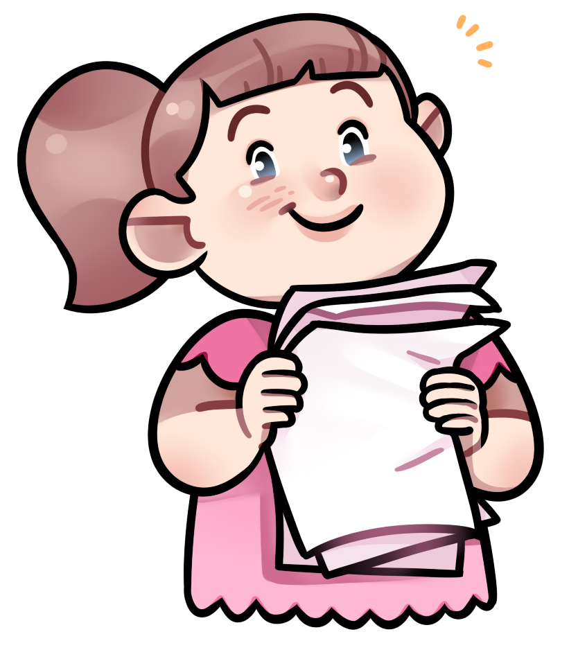
“Good luck!” Melissa said. “I would love to choose the theme for the class project. I have a great idea for it.”
Laura suddenly felt funny. Melissa didn’t just want to win; she wanted to help the class.
“Would anyone like to tell the class why they should be this month’s class leader?” Mrs. Perkins asked.
Laura raised her hand. “I think everyone should vote for Melissa. She has a great idea for the class project, and she always helps Mrs. Perkins pass out papers. She’d make a great class leader.”
Everyone nodded.
“Thanks,” Melissa said. “But I thought you wanted to be the class leader.”
Laura shrugged. “There’s always next month.”

About the Author

Kelly Hashway's picture book, May the Best Dog Win, is now available!

Dash has the perfect life until the Super Sweeper 5000 shows up. Sweeper runs all over the house sucking up the leftover food scraps, and he even gets his own room! But Dash won't give up his place as the favorite dog without a fight.

Hashway, Kelly. May the Best Dog Win. ISBN: 9780984589081

Name: __________________________________

Class Leader
by Kelly Hashway

1. Why did Melissa want to become class leader?

a. She liked to compete in contests and win.
b. She wanted to wear the gold badge.
c. She wanted to help the class.
d. She wanted to beat Laura.

2. Why did Laura want to become class leader?

________________________________________________________________________

________________________________________________________________________

3.

Duties of the
Class Leader

4. What lesson does Laura learn in this story?

a. It is more important to win than keep your friends.
b. Friendship is more important than winning a contest.
c. Being class leader is a big responsibility.
d. You should always volunteer for new activities.
Name: ____________________________

Class Leader
by Kelly Hashway

The words below are scrambled words from the story.
Unscramble each word and write it on the line.

1. a d
e g b _________________________________

Clue: piece of metal or plastic worn to show your position, rank, or duty

2. n n n n m c
o a e e u t _________________________________

Clue: something important said to a group of people

3. t e a m
n n i o _________________________________

Clue: to appoint or suggest someone for a position

4. d a e s
n c n _________________________________

Clue: glanced at something written; read quickly

5. e s r i p y o
t i l i b n s _________________________________

Clue: being accountable for; being trusted to do what's right

6. o c m t
e p e _________________________________

Clue: to try to win over someone else

ANSWER KEY

Class Leader
by Kelly Hashway

1. Why did Melissa want to become class leader? c

a. She liked to compete in contests and win.
b. She wanted to wear the gold badge.
c. She wanted to help the class.
d. She wanted to beat Laura.

2. Why did Laura want to become class leader?

She wanted to wear the gold badge. She loved contests and liked competing and winning.

3.
pass out papers distribute materials

Duties of the
Class Leader

write on the blackboard decide on a theme for
the class project

3. What lesson does Laura learn in this story?

a. It is more important to win than keep your friends.
b. Friendship is more important than winning a contest.
c. Being class leader is a big responsibility.
d. You should always volunteer for new activities.
ANSWER KEY

Class Leader
by Kelly Hashway

The words below are scrambled words from the story.
Unscramble each word and write it on the line.

1. a d
e g b badge

Clue: piece of metal or plastic worn to show your position, rank, or duty

2. n n n n m c
o a e e u t announcement

Clue: something important said to a group of people

3. t e a m
n n i o nominate

Clue: to appoint or suggest someone for a position

4. d a e s
n c n scanned

Clue: glanced at something written; read quickly

5. e s r i p y o
t i l i b n s responsibility

Clue: being accountable for; being trusted to do what's right

6. o c m t
e p e compete

Clue: to try to win over someone else

